MC LDAP Integration Service
Installation Guide

About
The Maintenance Connection LDAP Integration Service is used to setup the links and mapping information from a LDAP source to the Maintenance Connection user list and access group settings. Once the configuration has been completed, a LDAP syncing service can be installed which will, on a scheduled basis, setup new users for MC access and update existing users with the appropriate access rights.
Table of Contents
About 1
Supported Configurations 2
Upgrading From A Previous Version 3
Upgrading From Any Version Prior To Version 3 3
Upgrading From Version 3 3
Configuration 3
Pre-Installation 4
Installation Process 4
Initial Installation 4
Configuring IIS for LDAP (Active Directory Only) 4
Configuring for LDAP (Novell Only) 5
Installing Automatic Login Pages Into Maintenance Connection 5
Starting the Service 5
Configuration Wizards in Detail 6
Launching the Configuration Application 6
Areas that can be Configured 6
Configuring the Connection to Maintenance Connection 7
Configuring the LDAP Directory Type to Connect To 8
Configuring Special Service Options and Sync Timings 8
Configuring Each License 10
Configuring the LDAP Directory Connection 10
Configuring LDAP Field Mapping (Active Directory Only) 11
Configuring LDAP Field Mapping (Novell Only) 12
Configuring LDAP Group Mapping 13
Test Tools 14
Sync 14
Display Users To Sync 14
Limited Sync 14

Supported Configurations
The LDAP Integration Service is a very flexible integration service and can be setup many different ways. While it is impossible to actually test every possible configuration here are some known good configurations. Some of these configurations may require additional licenses to work.
- Active Directory & Server 2003+ Single MC Database
- Multiple Active Directory Forests/Domains & Server 2003+ Single MC Database
- Active Directory & Server 2003+ Multiple MC Databases
- Multiple Active Directory Forests/Domains & Server 2003+ Multiple MC Databases
- Novell Groupwise Single MC Database
- Novell Groupwise Multiple MC Databases

Upgrading From A Previous Version

Upgrading From Any Version Prior To Version 3
Version 3 introduced many new concepts and features into the LDAP Integration Service. Due to the significance of the changes made the configuration and setup of previous versions cannot be automatically imported into the new software.
- Stop the Maintenance Connection LDAP Service using the Services tool in Windows.
- Start the configuration program.
- Click on Service Configuration, Uninstall the service.
- Close the configuration program.
- Backup the tool and configuration settings
- Delete the old tool and software.
- The old configuration tool can be run from the backup folder to enable easy discovery and transfer of settings from the old tool to the new service.
- Follow the standard installation process

Upgrading From Version 3
Upgrading from version 3 to a new release is a fairly quick and easy process.
- Download the upgrade exe file and place it into the install directory
- Run the upgrade exe. It will uninstall the previous service and upgrade files, leaving important configuration files untouched.
- The configuration will automatically start after the upgrade is complete.
- Configure any new settings (if new features have been added)
- Install and start the service

Configuration
Configuring the LDAP Integration service is explained in detail in the installation process. When making changes to settings the service should be stopped to ensure all settings are properly reloaded. After changes are complete start the service again.
Once setup is completed it is unlikely that extensive changes will need to be made. Individual settings can be changed (mostly) without concern for affecting other settings. With the wizard style interface all connected settings will normally be addressed at once to ensure no partial changes are made.

Pre-Installation
- Make sure that Maintenance Connection has been installed and is working consistently.
- Ensure that appropriate permissions have been granted within the LDAP directory to have either anonymous querying of the Domain or a user has been setup that has sufficient permissions.
- (Active Directory Only) Confirm that the IIS Server has been attached to the Active Directory domain.
- Download the install files.
- Ensure the Pre-Installation questionnaire has been filled out.

Installation Process

Initial Installation
Initial installation of the integration service is simply performed running the install program (default install directory: C:\Maintenance Connection\mc_ldapService\). Due to network security requirements the LDAP service should only be installed on the IIS server and not the SQL server (if separate).
Version 3+ of the LDAP Integration Service requires .NET 3.5 to be installed to work. The Microsoft installer for .NET 3.5sp1 has been included in the /preReq directory. This installer will install .NET 3.5sp1 or upgrade the existing installation to .NET 3.5sp1; it does require an internet connection to work. If .NET 3.5sp1 is already installed the installer will offer the ability to Repair or Remove the installation, in this case cancel the installer and continue with the rest of the installation.

Configuring IIS for LDAP (Active Directory Only)
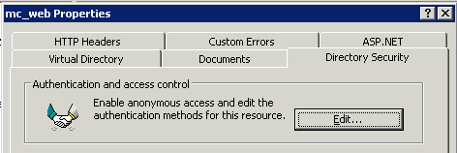
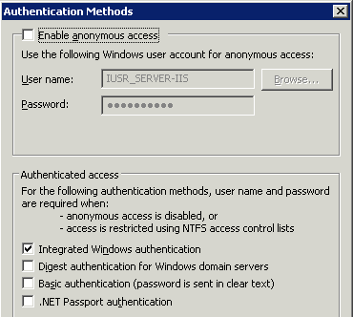
To enable the LDAP extensions in Maintenance Connection; IIS must be reconfigured to require authenticated access to the mc_web virtual directory. Due to the Maintenance Connection login system existing exclusively in the /onsite sub-directory, this is the directory that should have the security changed upon. This will leave Maintenance Connection to manage internal permissions without extensive reconfiguration.
- Open the IIS Manager.
- Navigate in the IIS Manager to the mc_web virtual directory.
- Navigate down to the /onsite sub directory in the mc_web virtual directory.
- Right mouse and select properties.
- Navigate to the Directory Security tab.
- In the Authentication and access control area, select Edit.
- Uncheck “Enable anonymous access”.
- Check “Integrated Windows authentication”.
- Make sure the other authentication methods are unchecked.
- Select OK and exit IIS Manager.

Configuring for LDAP (Novell Only)
No IIS configuration is required for the Novell automatic login process to work. All configuration changes are applied to client machines Internet Explorer settings.
The Novell automatic login process is handled though an ActiveX control that will be automatically installed upon accessing the login page. This ActiveX control is provided by Novell but is unsigned. The server that Maintenance Connection is installed on must be a trusted site for the login to work. Also the Internet Explorer security settings for the Trusted Sites zone must allow Unsigned ActiveX controls to run without prompting (otherwise additional clicks are required). For maximum compatibility IE 6 should be used, IE 7+ requires an extra click to login since it will not run unsigned ActiveX controls without confirmation each time.

Installing Automatic Login Pages Into Maintenance Connection
Once the LDAP integration is enabled the standard Maintenance Connection login pages do not function as a login page anymore. LDAP specific login pages need to be inserted to enable automatic login.
- Open the file browser.
- Navigate to the LDAP tool install folder.
- Copy all the files located in the “mc_iis -ad” folder and sub-folders. (Active Directory Only)
- Copy all the files located in the “mc_iis -novell” folder and sub-folders. (Novell Only)
- Paste the files into the “\Maintenance Connection\mc_iis\” folder.
- No files will be overwritten, select “Yes” to overwrite if prompted.
- Open the IIS Manager.
- Navigate in the IIS Manager to the mc_web virtual directory.
- Right mouse and select properties.
- Navigate to the Documents tab.
- In the “Enable default content page” area select add.
- Add “default_ldap_AD.asp” (Active Directory Only)
- Add “default_ldap_NOVELL.asp” (Novell Only)
- Press “Move Up” until the newly added default page is on the top of the list.
- Select OK, apply, and exit IIS Manager.
- If you wish to fully disable manually typed access to the old login pages (they don’t work for LDAP login regardless):
  - Rename the file extension of \mc_iis\default.htm to default.htm_
  - Rename the file extension of \mc_iis\default.asp to default.asp_
  - This 2 step process must be repeated for each version upgrade of Maintenance Connection.

Starting the Service
Once the service has been successfully configured and tested it can be installed and started. Installing and starting the service is controlled from the Service Information tab in the configuration application. See “Launching the Configuration Application” for a screenshot and details of how to start the configuration application.

Configuration Wizards in Detail
This configuration section applies to existing installations as well as new installs. All configuration steps are the same regardless of if the product is already installed and configured. The only exception to this is an existing installation does not need to re-insert configuration information that is already present.
You cannot change configuration options while the service is running. Always stop the running service (can be done in the configuration application) before performing any changes to the configuration.

Launching the Configuration Application
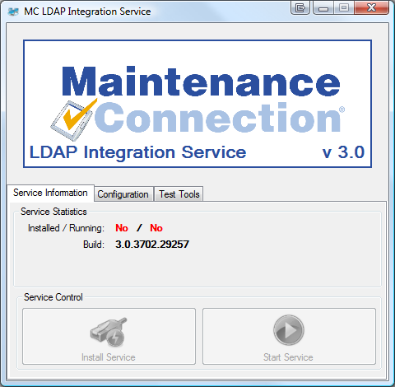
To launch the configuration application, double click on the Configure.exe application.
Launching Configure.exe may display a UAC elevation prompt. Select accept to enable the configuration program to properly launch.
Once running you will see a screen similar to the one to the right.

Areas that can be Configured
To the left is a screenshot of the various configuration wizards that can be used to configure the LDAP Integration Service. These configuration wizards are explained in the sections below.
Configuration can only occur when the service is not running.

Configuring the Connection to Maintenance Connection
Configuring access to Maintenance Connection is the first step to having the LDAP Integration Service running. Launch the configuration wizard by selecting the MC Connection Configuration button on the Configuration tab. The wizard will launch and step you through connecting to Maintenance Connection.
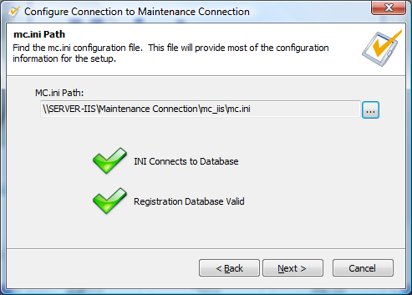
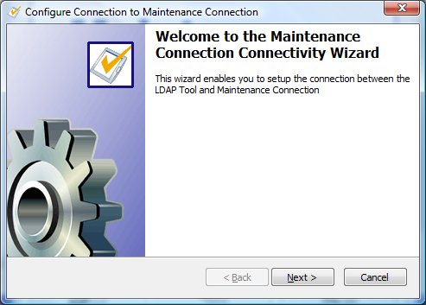
To the left you will see the title screen of the wizard. This explains what the purpose of the wizard is. Select next.
On the next page (right) you will select the location of the mc.ini file. This file contains the required connection information to connect to the Maintenance Connection databases. Once the file is selected a test is performed to ensure the INI information can successfully connect to the database and that the database selected is considered a valid Registration database. Select next.
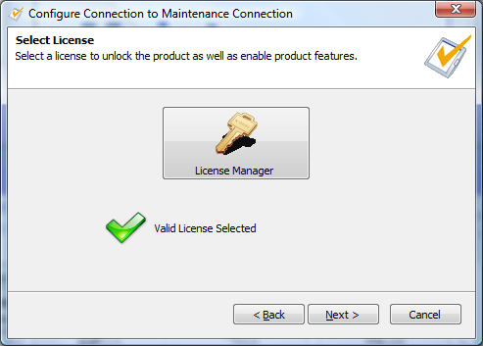
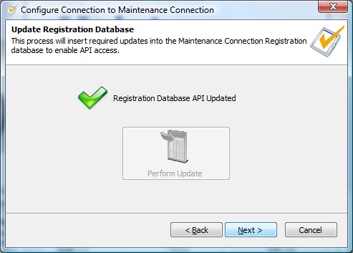
On the next page (left) you will have the ability to upgrade the Registration database with new functions, tables, and columns to enable the LDAP service to run successfully. This is essential to error free execution of the service. This should be checked on each upgrade of the service incase new features have been added to the database. If an update is required a red X will be displayed and the Perform Update button will be selectable. Perform the update if required and then select next.
On the next page (right) you will select the license to unlock the LDAP Integration service. This will allow the LDAP Integration service to be able to execute properly and display only the most relevant configuration options. If you need assistance with the License Manager please contact your Maintenance Connection administrator. Once the license has been selected it will be validated and you will be able to select next.
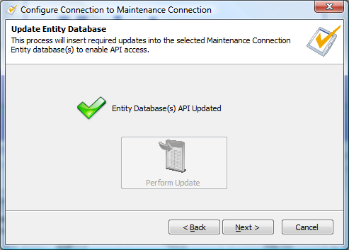
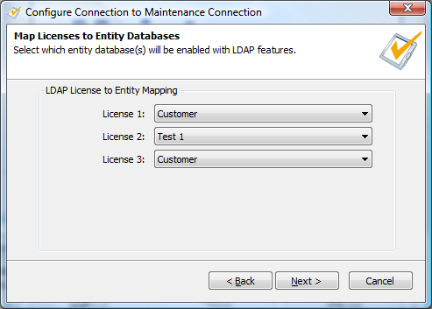
On the next page (left) you will be able to map the available LDAP licenses to Maintenance Connection databases. Depending upon your available licenses and system configuration there will be 2 different situations. Mc.ini is already mapped to an Entity database, just select next /or/ 1 or more available licenses to map. Select the Entity database from the drop down list and then select next.
On the next page (right) you will have the ability to upgrade the entity database(s) with new functions, tables and columns to enable the LDAP service to run successfully. This is essential to error free execution of the service. This should be checked on each upgrade of the service incase new features have been added to the database. If an update is required a red X will be displayed and the Perform Update button will be selectable. Perform the update if required and then select next.
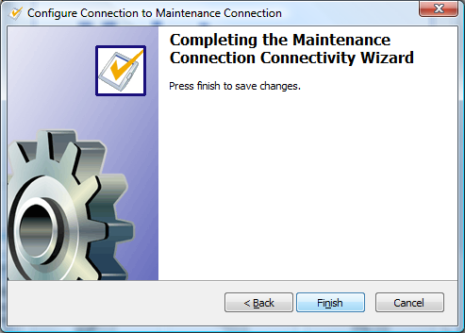
On the last page (left) you will be able to save your changes or cancel. Select finish to save your changes or select cancel to throw out your changes.

Configuring the LDAP Directory Type to Connect To
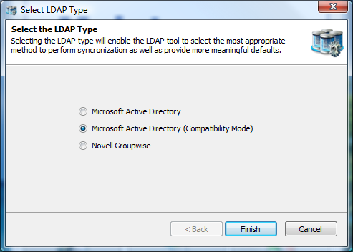
This allows you to change which type of LDAP directory you will connect to. The three available options are:
- Microsoft Active Directory
- Microsoft Active Directory (Compatibility Mode)
- Novell Groupwise
Select the appropriate option for the LDAP directory you will be using. Active Directory Compatibility Mode is available for instances where Active Directory 2003 is running in compatibility mode with Active Directory 2000, or has some required features disabled. This mode may not offer 100% of available functionality.
Select finish to save your changes.

Configuring Special Service Options and Sync Timings
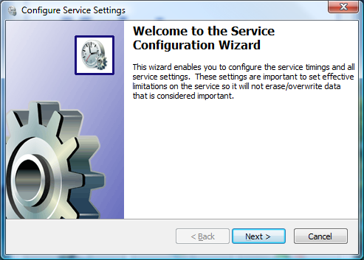
This wizard allows you to configure how the service will operate in the background.
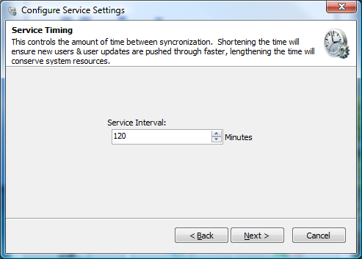
To the left you will see the title screen of the wizard. This explains what the purpose of the wizard is. Select next.
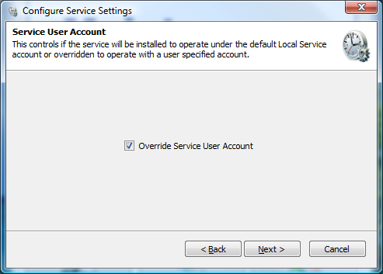
On the next page (right) you will be able to configure the service interval. This is how often the service will attempt to synchronize between the LDAP directory and Maintenance Connection. Selecting a longer interval will mean that LDAP directory changes will take longer to appear into Maintenance Connection, a shorter interval will cause changes to appear sooner. Select next.
On the next page (left) you will be able to configure if the service will prompt for a special user account when installing the service. By default the service will install under the Local Service account, if this account does not have sufficient permissions to access the network (and LDAP) you will need to override the account with a different one. When you install the service it, Windows will prompt for a User Account and Password if this is enabled. Select next.
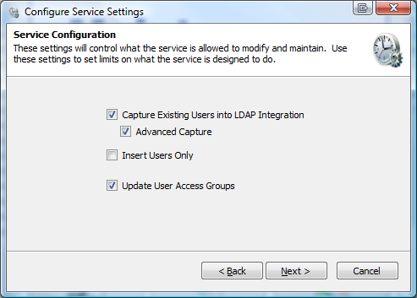
On this page (right) you will be able to configure how users are managed in the LDAP service. The options are explained here:
- Capture Existing Users into LDAP Integration
This option will allow the service to look at user accounts already in MC and attempt to find a valid mapping with a LDAP user account.
- Advanced Capture
This is an advanced form of the previous option it will attempt to use more advanced means of capturing existing users, including looking at Labor IDs and e-mail addresses. This is will enable the next page so that you can select which advanced methods to use. If a method is enabled that should not be matching behavior will not be as expected.
- Insert Users Only
This option will not update MC if a LDAP user’s account changes. This is used if the service is supposed to populate the MC database but maintenance of the users is intended to be inside Maintenance Connection.
- Update User Access Groups
This option controls if the service should keep a users Access Group matched up to the LDAP directories groups. Disabling this enables Access Groups to be changed inside of Maintenance Connection. Enabling this will cause changes to a users Access Group (in MC) to be automatically reverted to the setup in the LDAP directory.
Select next.
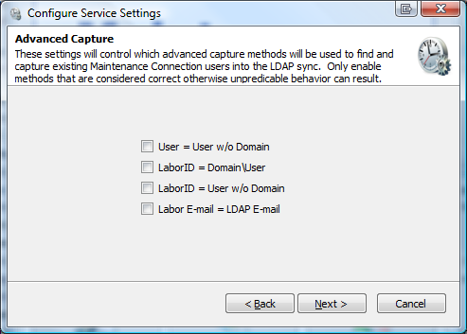
On this page (left) you will be able to select which advanced capture methods to enable. Make sure that capture methods that don’t make sense for the installed Maintenance Connection environment are not enabled. If for instance many users use the same e-mail address, disable the e-mail address mapping otherwise a user could be “randomly” assigned to an existing user account based upon an e-mail address match.
Once the methods to perform advanced mappings with have been selected, click next.
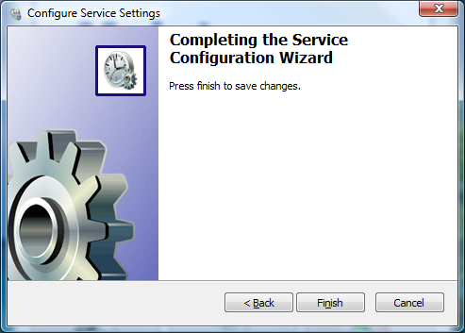
Click the finish button to save your changes and close the wizard.

Configuring Each License
Each installed LDAP license must be configured independently to connect to LDAP. This enables the ability to connect to multiple domain servers and/or have multiple databases or types of specific group mappings.
As shown above the bottom half of the configuration tab is headed by a second set of tabs. Each tab represents a configured license and displays the name of the Entity database each license has been configured to connect to. To change these mappings see the instructions in “Configuring the Connection to Maintenance Connection”.

Configuring the LDAP Directory Connection
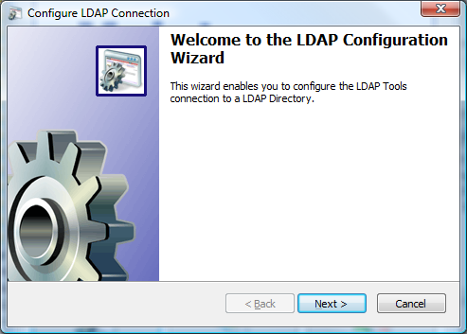
Ensuring a properly setup connection to the LDAP directory is integral to having the entire integration service work.
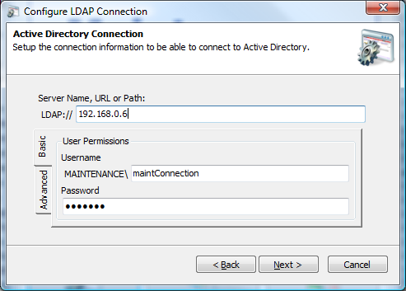
To the left you will see the title screen of the wizard. This explains what the purpose of the wizard is. Select next.
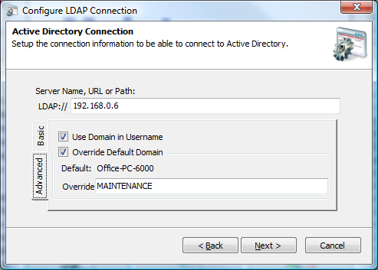
(Active Directory Only) To the right you will see the primary configuration for connecting to an Active Directory domain server. Fill in the LDAP path and a username & password for the connection. The username & password are optional though may be required depending upon the configuration of the domain server.
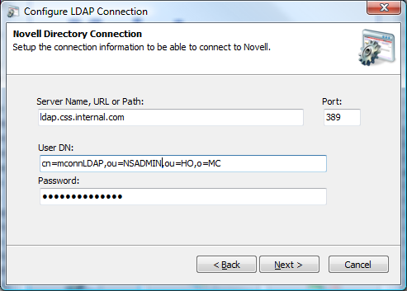
To the left is the advanced tab. This is used to change a few advanced settings for connecting to the domain server. If the domain server does not report usernames with the domain included uncheck the “Use Domain in Username”. If the domain name being reported is not the domain name the server uses, for example multi-domain environment, override the domain name and type in the correct name. Once finished select next to continue.
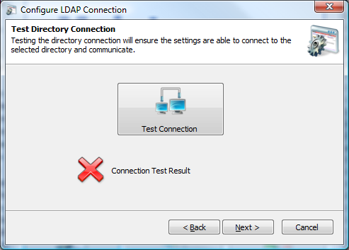
(Novell Only) To the right is the primary configuration for connecting to a Novell LDAP directory. Fill in the directory path and port number. Connecting to a LDAP directory also requires a fully qualified user distinguished name and the user’s password. Once finished select next to continue.
To the left is the wizard screen that allows you to test the connection to the LDAP directory. A connection attempt is made immediately upon going to the page. If the attempt fails a red X will appear; if it succeeds a green checkmark will be displayed. To receive a popup with error results select the Test Connection button. Once a connection is achieved select next.
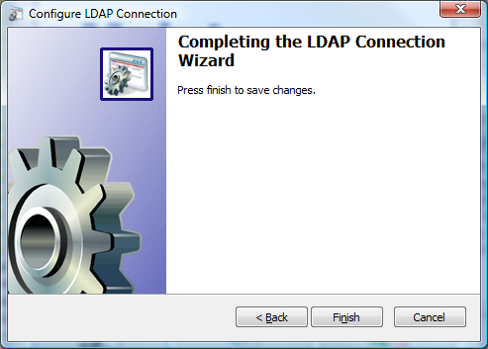
Select finish to save the changes.

Configuring LDAP Field Mapping (Active Directory Only)
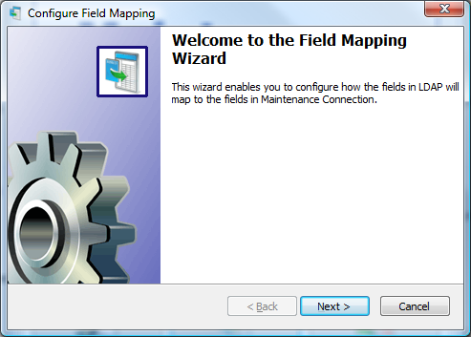
Configuring the field mappings ensure that the correct information flows from LDAP into Maintenance Connection. Due to many fields in Active Directory being predefined by the system, several fields have fixed defaults.
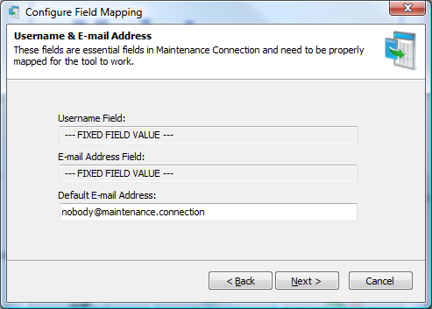
To the left you will see the title screen of the wizard. This explains what the purpose of the wizard is. Select next.
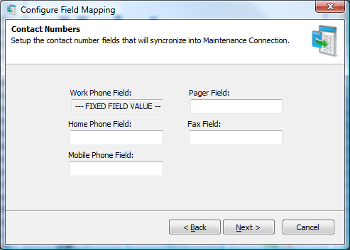
To the right is the screen for configuring the default e-mail address of a user to be synchronized into Maintenance Connection. It is possible to insert users into Active Directory that do not have an e-mail addresses specified. Maintenance Connection does not allow this behavior and all users must have an e-mail address pre-defined. To allow for syncing users without a configured e-mail address you must setup a fallback e-mail to use. Any e-mail address, including invalid ones is acceptable. Select next.
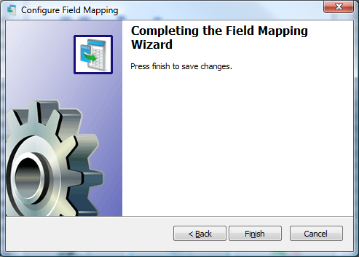
To the left is the screen for configuring user phone numbers. If a field is configured and it does not contain any data the corresponding information in Maintenance Connection will not be overwritten. A non-configured field will not be synchronized. Select next.
Select finish to complete the wizard and save changes.

Configuring LDAP Field Mapping (Novell Only)
Configuring the field mappings ensure that the correct information flows from LDAP into Maintenance Connection. Since standard LDAP directories do not have a long list of pre-defined fields there are many fields that need to be configured for a successful sync.
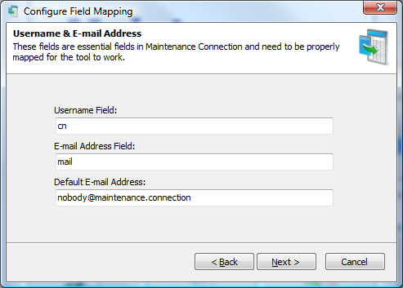
To the left you will see the title screen of the wizard. This explains what the purpose of the wizard is. Select next.
To the right is the screen where you will configure the LDAP fields for the Maintenance Connection username, the e-mail address and the default e-mail address to use in Maintenance Connection if an e-mail address is not available in the LDAP directory. Once configured select next.

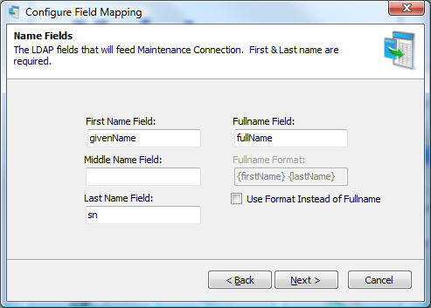
To the left is the screen where you configure what fields give a user their name. A full name format can be used instead of a field from the directory; anything can be hardcoded into the format. Available dynamic fields are: {firstName}, {middleName} and {lastName}. Select next when finished.
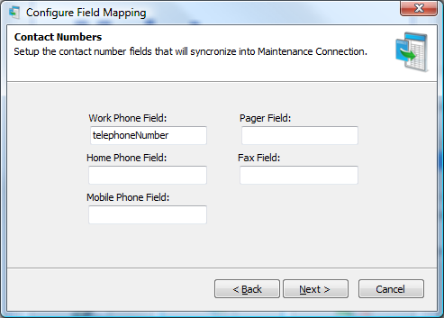
To the right is the screen for configuring user phone numbers. If a field is configured and it does not contain any data the corresponding information in Maintenance Connection will not be overwritten. A non-configured field will not be synchronized. Select next.
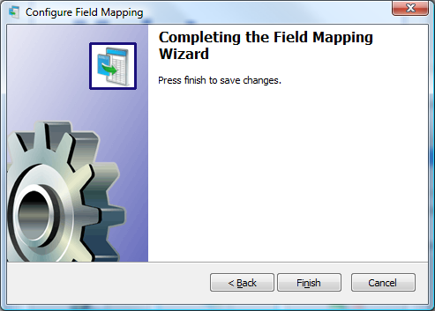
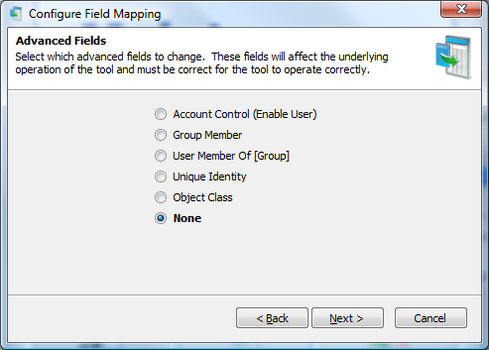
To the left is the advanced fields wizard page. This page leads to special advanced fields configuration pages. Each advanced field needs to be correctly configured for full operation. Once finished change the setting to None and click next.
Select finish to complete the wizard and save changes.

Configuring LDAP Group Mapping
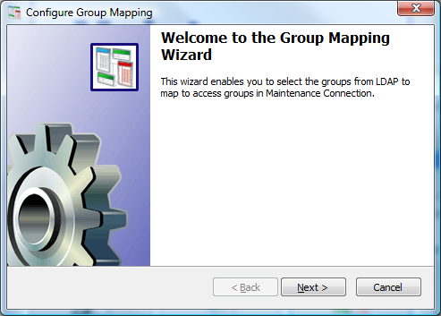
The group mapping wizard enabled mapping groups from LDAP to a matching access group in Maintenance Connection.
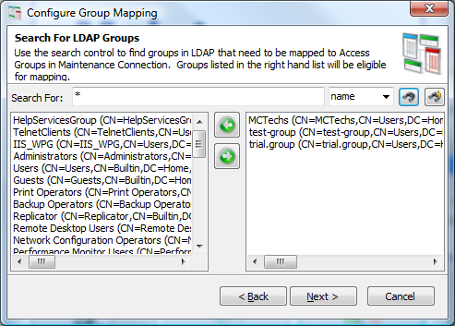
To the left you will see the title screen of the wizard. This explains what the purpose of the wizard is. Select next.
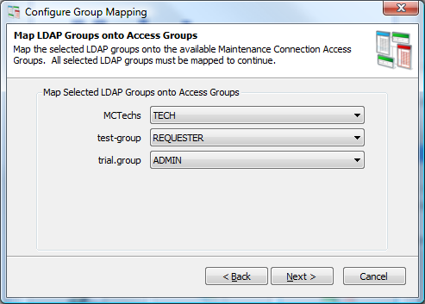
To the right is the search for LDAP groups screen. This screen allows you to filter through the entire directory of LDAP groups to a select few groups that should be mapped to Maintenance Connection. Wildcard searches are allowed. Search results appear on the left, select a result to map and select the right pointing arrow to add it to the mapped groups list. Once all the groups that need to be mapped are selected, click next.
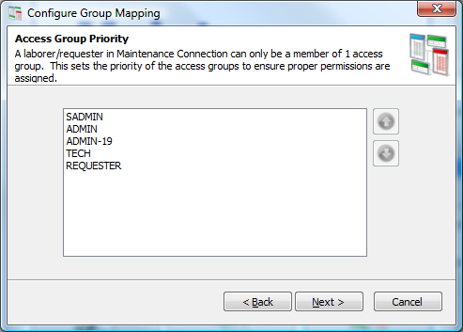
To the left is the screen for mapping selected LDAP groups to a Maintenance Connection access group. The LDAP groups that were selected are listed on the left and a dropdown list offering available Maintenance Connection access groups is on the right. Once all the mappings have been set, click next.
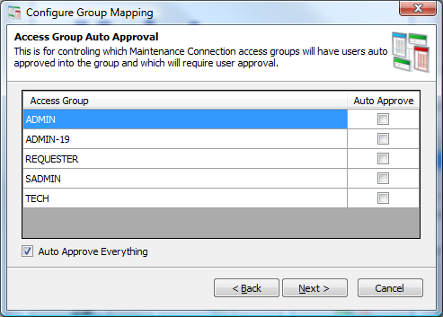
To the right is the screen for setting Maintenance Connection access group priority. Access groups in Maintenance Connection can only have a single group assigned to a user. This requires that if a user happens to be in 2 mapped LDAP roles, the correctly prioritized access group will be selected. Once the priorities are ordered correctly, click next.
To the left is the screen for setting auto approvals in Maintenance Connection. This will configure if certain access groups will need manual intervention before they are fully approved for use in Maintenance Connection. The default is to approve everything. Once configured, click next.
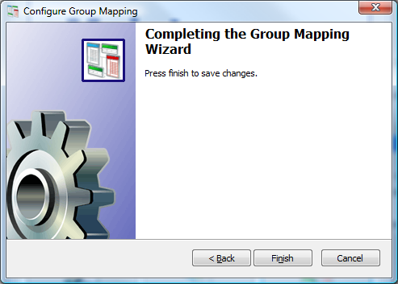
Click finish to complete the wizard and save your changes.

Test Tools
To the left is a screenshot of the available test tools. These tools are used to perform various actions between the LDAP directory and Maintenance Connection. Some of these processes can be destructive processes and should be used with caution; backing up of the database is recommended.

Sync
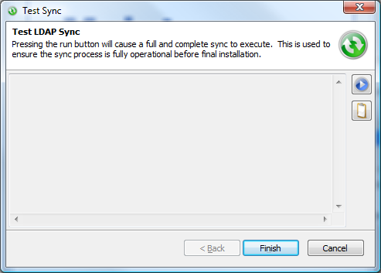
This test tool performs a full and complete sync. This is used to confirm that the tool is fully setup correctly or if a change has been made to the configuration and you do not wish to wait for a sync cycle to occur.
The play button executes the sync. In the case of issues occurring during the sync the clipboard button is available to copy the entire sync log to the clipboard for easier identification or sending in an e-mail.

Display Users To Sync
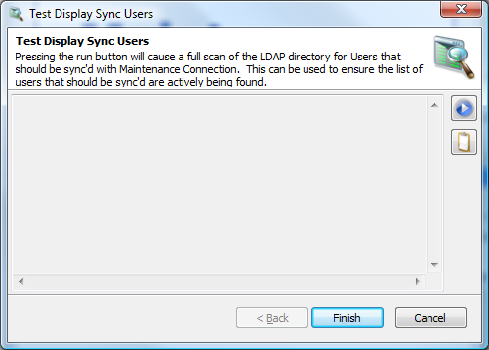
This test tool performs what might be considered “sync light”. This is a non-destructive process that will execute a standard sync to simply identify which users are expected to be synced. Standard Maintenance Connection database operations are not performed.
This is used to confirm that all the users that are expected to be found are actually being found.
The play button starts the users search. The clipboard button will copy the search results to the clipboard.

Limited Sync
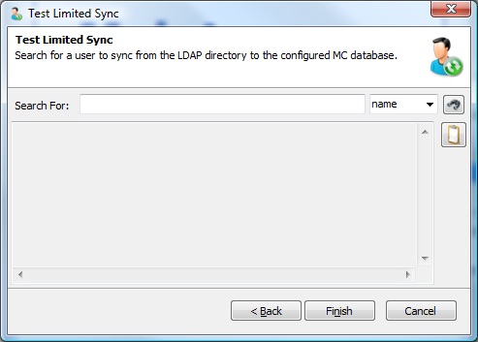
This test tool performs a limited version of the standard sync. It will search for a single user in the LDAP directory and attempt to sync that user into Maintenance Connection. In the case of multiple licenses, you will first need to select the license to use.
Type the name in the search box and select the find button to begin the search. Wildcard searches are acceptable and multiple users can be synced at a time using this tool. The clipboard button will copy the sync results to the clipboard.

