Maintenance Connection
Installation Process
Table of Contents
Installation Process 2
Overview 2
Initial Installation 2
IIS 6 Setup 2
IIS 7 & 7.5 Setup 3
Maintenance Connection Setup Manager 4
Start the Setup Manager 4
System Setup 4
Company Setup 5
Registration Database Job 6
Database Backup 6
Appendixes 7
Preventing E-mails From Being Marked As Spam 7
Named Instances of SQL Server 8
Configuring Server 2008+ for Speed 8
Restoring MC Databases Manually 8

Installation Process

Overview
This is the general overview of installing Maintenance Connection. The installation overview will point to each section of detailed install instructions. Some of the detailed instructions will not be required depending upon the server setup being used. This installation guide does not explain the installation process for any operating system prior to Windows Server 2003.
- Ensure the pre-installation checklist has been filled out and all customer required server setup steps have been completed.
- Follow the initial installation
- In a Server 2003 environment follow the IIS 6 Setup
- In a Server 2008 or 2008 R2 setup follow the IIS 7 or 7.5 Setup
- There are appendixes for various situations that may be encountered during setup

Initial Installation
Initial installation of Maintenance Connection is simply performed by running the install program (default install directory: C:\Maintenance Connection\). For efficiency of installation ensure that any required updates are already downloaded and available on the server that Maintenance Connection will be installed on.
While a basic installation of Maintenance Connection does not require .NET to operate many add-ons do. During the base installation of Maintenance Connection is an excellent time to ensure that .NET 3.5sp1 has been installed.
Create a subdirectory in the “install dir\mc_imageserver\” directory for each company database you plan to install. The subdirectory should be named after the entity database to be created entXXXX.
In each of the directories created place a copy of the customer’s logo. The maximum picture size allowed will depend upon the standard screen resolution used to access Maintenance Connection. In most cases the logo should be no larger than 300x300 pixels and in many cases should not exceed 150x150 pixels. The picture does not need to be square. The file format for the picture must be a standard internet file type like BMP, GIF, JPEG or PNG. Make note of the file name for later use.

IIS 6 Setup
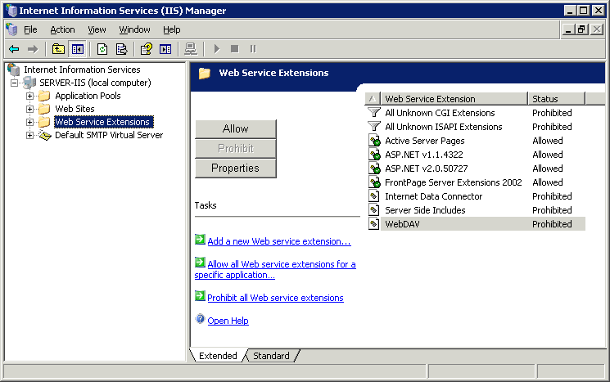
- Open the IIS Manager.
- Navigate to Web Service Extensions
- Make sure that Active Server Pages is “Allowed”.
- Make sure that ASP.NET v2.0.50727 is “Allowed”.
- Navigate to the website that Maintenance Connection will be installed under (this is usually the Default Web Site)
- Create a new Virtual Directory under the web site (right click New Virtual Directory)
  - Name: “mc_web”
  - Directory: “install dir\mc_iis\”
  - Permissions: Read [Only] and Scripts
- Open the properties for the newly created virtual directory (right click Properties)
  - Make sure, under Pools, that the app is in the default app pool
  - Enable Parent Paths (Virtual Directory Tab Configuration button Options Tab)
  - Enable Content Expiration (HTTP Headers Tab)
  - Have the content expire after n days. (recommended 30 – 90 days)
- Create a new Virtual Directory under the web site (right click New Virtual Directory).
  - Name: “mc_imageserver”
  - Directory: “install location\mc_imageserver\”
  - Permissions: Read [Only]
- Open the properties for the newly created virtual directory (right click Properties)
  - Enable Content Expiration (HTTP Headers Tab)
  - Have the content expire after n days. (recommended 30 – 90 days)
- Create a new Virtual Directory under the web site (right click New Virtual Directory).
  - Name: “mc_help”
  - Directory: “install location\mc_help\”
  - Permissions: Read [Only]
- Open the properties for the newly created virtual directory (right click Properties)
  - Enable Content Expiration (HTTP Headers Tab)
  - Have the content expire after n days. (recommended 30 – 90 days)
- Close IIS Manager.

IIS 7 & 7.5 Setup
- Open IIS Manager
- Navigate to the website that Maintenance Connection will be installed under (this is usually the Default Web Site)
- Create a new Application under the web site (right click Add Application…)
  - Alias: “mc_web”
  - Directory: “install dir\mc_iis\”
  - Application Pool: Must be either Classic .NET AppPool or a custom pool with the pipeline mode set to classic.
- Open the ASP Feature and enable Parent Paths
- Create a new Virtual Directory under the web site (right click Add Virtual Directory…)
  - Alias: “mc_imageserver”
  - Directory: “install dir\mc_imageserver”
- Create a new Virtual Directory under the web site (right click Add Virtual Directory…)
  - Alias: “mc_help”
  - Directory: “install dir\mc_help”
- Close IIS Manager

Maintenance Connection Setup Manager

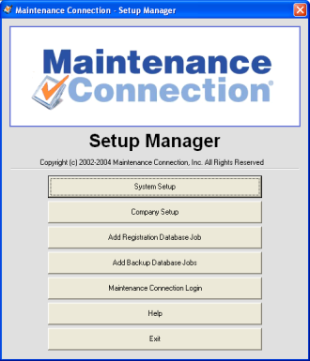
Start the Setup Manager
- Using Windows Explorer, navigate to the “install dir”.
- Run “mc_setup.exe”
The Setup Manager will setup the Registration and the Company Databases. It will also register the supporting DLL’s and initialize the information Maintenance Connection needs.

System Setup
The system setup is used to inform Maintenance Connection where the databases are located as well as various account and communication information to enable Maintenance Connection to function properly. Start the setup by clicking the System Setup button
- Fill out the Registration Database Access information first
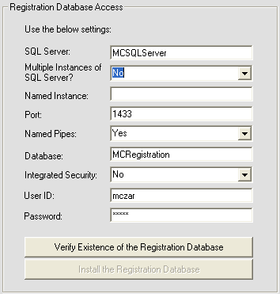
  - SQL Server: The name of the SQL Server
  - Multiple Instances: Set to ‘yes’ if you have more than one SQL Server Instance on the SQL Server
  - Named Instance: Fill in if Multiple Instances is set to yes.
  - Port: The SQL Server Port. Usually 1433, sometimes 1432.
  - Named Pipes: Usually ‘yes’ set to ‘no’ if not using named pipes.
  - Database: This is the name of the Registration Database, usually “mcRegistrationSA”.
  - Integrated Security: Leave as ‘no’.
  - User ID: The SQL Server user ID, should be ‘mczar’.
  - Password: The SQL Server user password, should be ‘mczar’.
- Click the Verify Existence button (alternate database restore option, see Appendix 1).
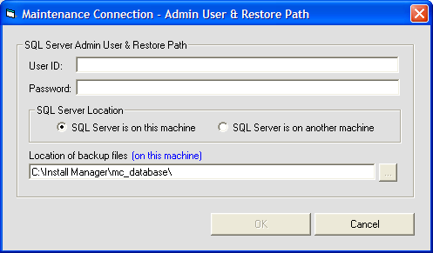
  - User ID: This is the user ID for the SQL Server system admin account (usually sa).
  - Password: This is the password for the system admin account.
  - SQL Server Location: If the SQL server is on this machine or a remote machine. This tells SQL Server were to create the databases.
  - Location of the backup file: This is the location of “\Maintenance Connection\mc_database” folder from the SQL Servers perspective. If the SQL Server is a different machine then you need to copy the mc_database folder onto that PC.
  - Select the OK button to create the database and/or the user.
- Next, fill out the Company Database Access information.
(Note: You will need to check the use single company checkbox if it is not already checked.)
If you are setting up a demo database as well as a customer database – make sure this check box is NOT selected.
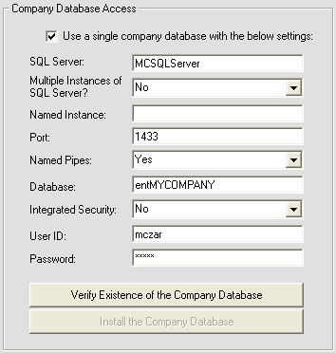
  - This information should be the same as the Registration Database Access information, except for the Database field.
  - Database: This is the name of the Company Database. The first three letters should be ‘ent’ all lower case. The next part is the Abbreviation for your company, all upper case. Example: MYCOMP, MAINTCON, or XYZ.
- Click the Verify Existence button.
Note: until you hit the Save button, the records in mcRegistrationSA’s Container and Container_Resource tables are not added! If you hit Cancel – the database will be created but the database records are not.
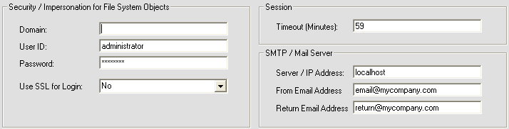
  - When prompted to install the Company Database, click yes and complete the following screen the same as when installed the registration database
- Next, fill out the Security, Session, and SMTP fields.
  - Domain: This is used for File System Object Impersonation. If you are using a local user account, you can leave this field blank. Note: There are problems on some systems with Domains. In general – create a LOCAL USER and use that user for Object Security.
  - User ID and Password: This is the login for a Windows User that has right to file manipulation.
  - Use SSL for Login: If using SSL, set this to ‘Yes’.
  - Session: Set the timeout to 59 if not already set.
  - SMTP / Mail Server: Fill in the IP or Server Name of your SMTP Server.
  - From & Return Email Address: These addresses are used when sending emails from the Reports Module. A good example of what they should be is provided in the image above. You may need to create the email accounts.
- Click Save once all the steps are completed.

Company Setup
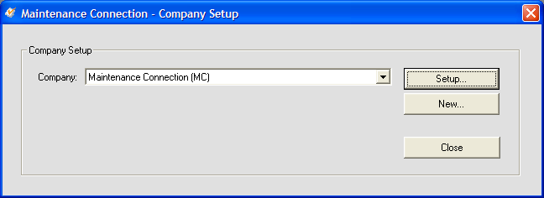
- From the main screen click Company Setup
- Click the setup button
- Fill in the company information first
  - Company ID: Fill this in as the abbreviation for your company, all upper case. This should be the same as the company database name without ‘ent’.
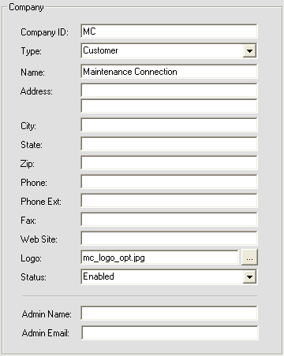
  - Fields ‘Name’ down to ‘Website’ are informational only. Fill in as much as you need.
  - Logo: If you have a logo, use the browse button to find it. The file must be located in “\Maintenance Connection\mc_imageserver\ent” + company abbreviation.
If you don’t have a logo this field should be blank.
  - Admin Name: This name is used when new signups are being requested.
  - Admin Email: This is the email for the administrator of the software.
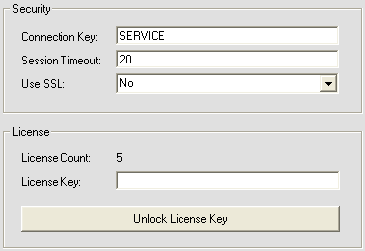
- Next fill in the Security and License information.
  - Connection Key: This is used when new users are signing up for the software.
  - Session Timeout: Set this to between 20 and 59. Anything over 59 will cause an error in Internet Explorer.
  - License Key: This is used to update your number of licenses. Fill in with the License Key that Maintenance Connection provided you and then click Unlock License Key. If prompted to save, click yes.
- Ensure the SQL Server location is correct. If not then enter the correct server name. If using named instances ensure the server name is “servername\instancename”.
- Click save to exit this screen.

Registration Database Job
- Click Add Registration Database Job.
  - This will create a SQL Server Job that will clean up old sessions each night at 2:00am
  - You may be prompted for the SQL Server administrator user name and password.

Database Backup
Backing up the database regularly is an important part of setting up Maintenance Connection. In the case of simple Maintenance Connection installations we provide a simple (though unsupported) backup process. It is up to the customer to decide if they will rely upon this backup process or purchase a more reliable backup process to backup both Maintenance Connection databases as well as other databases the customer might have.
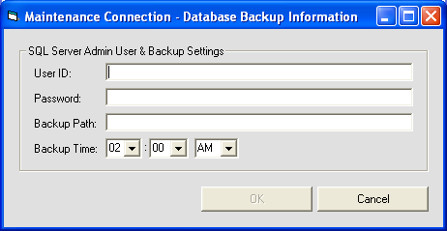
- If you would like to create Backup Jobs, click on Add Backup Database Jobs.
  - User ID: This is the System Admin (sa) user for the SQL Server.
  - Password: The System Admin password for the SQL Server.
  - Backup Path: This is the path to the folder where you would like your backups stored.

Appendixes

Preventing E-mails From Being Marked As Spam
E-mail servers have been getting more “vigilant” in their fight against spam. This means that an incorrectly configured SMTP server can send e-mails that will all be blocked as spam. Some e-mail servers won’t even deliver certain types of SPAM messages to the end user.
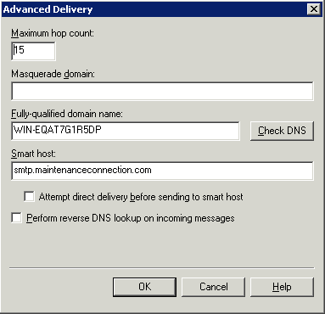
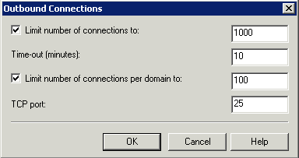
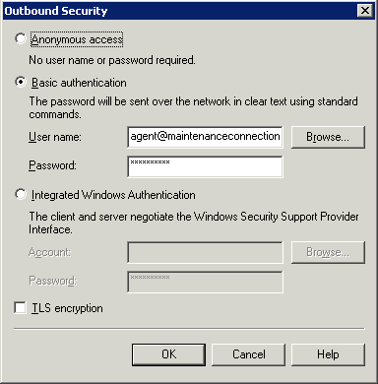
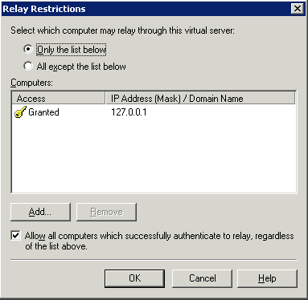
To this end ensuring that the SMTP server has been correctly configured is incredibly important for successful delivery of e-mail. Since MC is unable to send e-mail via an SMTP server that requires authentication (and most do now) the local SMTP virtual server will need to be configured in many cases. This SMTP server is quite effective but many e-mail receivers may see e-mails sent by it as spam e-mails. To combat this the SMTP server must be setup to relay messages to the normal SMTP server (the one that requires authentication).
- Install the Virtual SMTP server. In the case of Server 2008+ you will also need to install the IIS 6 compatibility.
- Start the IIS 6 Manager
- Select the SMTP server right click and select properties
- Navigate to the Access tab select Relay
- Ensure that 127.0.0.1 has been added to the computers list and “Only the list below” is selected.
- Select OK
- Navigate to the Delivery tab
- Select Outbound Security
- Select the proper authentication type to communicate with the other SMTP server (normally “Basic authentication”)
- Enter the user and password required to log into the remote SMTP server
- Select OK
- If the remote SMTP server uses a different port than the default (25), select “Outbound connections” and change the TCP port to the correct port number.
- Select Advanced
- Enter the name or IP address of the remote SMTP server in the Smart host field.
- Uncheck “Attempt direct delivery” and “Perform reverse DNS”
- Select OK
- Select OK to finish the configuration.
- Test the settings by sending a test e-mail from Maintenance Connection.

Named Instances of SQL Server
When configuring Maintenance Connection with named instances there are some special considerations that must be managed or Maintenance Connection will not work successfully.
- Do not use the “Named Instances” fields in the Maintenance Connection setup. While this may work for Maintenance Connection it is not stored in the database and other addons will be unable to access the database.
- The database server must be specified with the “server name\instance name” syntax.
- In some cases this will be too long for the database to handle.
  - To manage this you must change the field length of the fields in the database and specify the server name in the database.
- Test connections to ensure a connection is made.
- If the server name is specified via an IP address the “SQL Server Browser” service must be running and the ports open in the firewall for a connection to be made.
- For each configured entity database ensure that the database name is also declared similarly.

Configuring Server 2008+ for Speed
There are some minor but notable differences in the inner working of Server 2008+. These differences can cause artificial slowdowns of Maintenance Connection due to the differences between Server 2008 and Server 2003. There are a few adjustments to how the system is configured that can assist with restoring the standard speed of Maintenance Connection.
- When configuring access to the SQL databases in Maintenance Connection, use the database servers IP address instead of the name. This will speed up connections to the SQL server from Maintenance Connection.
- To speed up connections to the SQL server even more enable the “SQL Server Browser” service. This service will also require firewall permissions to work properly.
- Disable dynamic content compression on each Application (Compression configuration)

Restoring MC Databases Manually
- Open Enterprise Manager or SQL Server Management Studio (SSMS)
- Drill down in the tree to the database server and the databases folder.
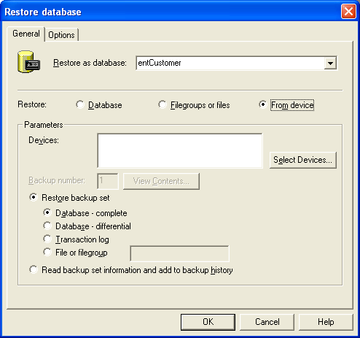
- Right click and select All Tasks Restore Database…
- Change the name of the database to restore as; this will be mcRegistrationSA or ent??? for customer databases.
- Change the restore type to From Device.
- Select: Select Devices…
- Select Add
- Type in the name of the database being restored or select the database using the ellipsis button (…)
- Select OK
- Select OK again
- Ensure that you select the backup set to restore (SSMS only)
- Select the Options tab
- Change the restore location of the database and log file to a valid directory location. Database files should end with “.mdf” and log files should end with “.ldf”.
- Select OK to begin the restore.
- Repeat steps 3-14 for each database being restored. Usually this will be mcRegistrationSA.bak and mcModel.bak. mcModel is used for restoring customer databases and should be restored as an ent??? database.
- Select the newly restored database and drill down to the users area.
- Select Add User
- Add a user named mczar and select the login mczar from the dropdown list.
- Make sure the user has db owner permissions.
- Done!

