Before Installing
- Decide with the customer what their database name will be. The name is required to be “entXXXX”, where XXXX is an abbreviation of the customer’s name.
- Discover if there are one (1) or two (2) computers involved, database server and web server. If there are two (2) computers involved discover the computer name of the database server.
- Ensure that the Systems Administrator has setup the web server so that it can connect to the database server. This means that port 1433 (usually) needs to be open between the web server and the database server.
- Discover if the Systems Administrator has setup the database server with non-default ports; if so find out the port that MS SQL Server is setup on. The appendix has the process to discover the SQL Server ports.
- If the database server is on a corporate machine, it may be necessary to walk their DBA through many of these steps.
- If the web server is on an existing IIS server, it may be necessary to walk their webmaster through many of these steps.
- If the web server is in a DMZ (demilitarized zone) the database server will need to be in the same zone OR their network administrator will need to ensure a connection is open between the web server and the database server.
- If the web server has firewall software and the customer wants MC to be accessible on the corporate network (intranet). The firewall administrator will need to open port 80 (required) and port 443 (if using SSL).
- If there is a hardware firewall and the customer wants MC to be accessible on the internet then the firewall administrator will need to open port 80 (required) and port 443 (if using SSL).
- Make sure if the customer is using MS SQL Server (this does not matter for MSDE), that they are using SQL Server 2000 or 2005. MC will not run properly on SQL Server 7.
The easiest way to check the version is:
- Run SQL Enterprise Manager
- Click down Console Root, Microsoft SQL Servers, SQL Server Group, then to the server (usually “(local) (Windows NT)”).
- Right click -> Properties
- On the General Tab it will tell you the Product version. It should be 8.x (or higher).

Preliminary Install Steps
- Install server grade (Windows 2000 or Windows 2003) or XP Pro (see note 1). Make sure that both the Web server and Database server are accessible throughout the install (see note 2).
Note 1) It is preferred to run with a Server grade operating system. SQL Server and IIS runs with limited functionality on an XP Pro machine. It is very easy to run out of connections on an XP Pro machine because of the limitations imposed.
Note 2) The Web server and Database server are referenced as if they are different machines throughout the install guide. This is usually the case but is not a requirement; they can be located on the same machine. If both the Web server and Database server is the same machine the instructions for both machines need to be carried out on the single machine.
- On the Web server, install IIS and if there is no other SMTP server, make sure the SMTP service is included. (Control Panel -> Add/Remove Components -> IIS -> Details -> SMTP service) The service should be setup to relay from 127.0.0.1 (IIS Manager -> “Default SMTP Virtual Server” -> right click -> Properties -> Access Tab -> Relay Tab, radio button ‘Only the list below’ selected, if 127.0.0.1 is not in the list add it.).
- On the Database server, install/verify that MS SQL Server 2000 or MSDE (see note 3 and 4) is installed. Service pack 2 or higher must be installed on SQL Server.
Note 3) MSDE is not recommended; it should only be used when cost is an issue and data volumes and use will be low.
Note 4) MSDE can be downloaded from http://www.maintenanceconnection.com/mcv18/mc_download/. SQL Server 2000 is a commercial product and must be purchased from Microsoft.
- If the Web server has a “_” in the computer name it must be changed. IIS does not store cookies properly when the computer has an underscore in the name.
- If installing the Palm Webservice verify that .NET 1.1 is installed. If installing the PPC Webservice verify that .NET 2.0 is installed on the Web server. (Add/Remove Programs should have it listed)
- Install virus protection software. Currently we recommend eTrust from www.ca.com.
- Run Windows Update to ensure the latest updates are all installed. It may take several iterations to get everything installed.
- Set the automatic update based on the customer’s policy. We recommend an automatic update at an early morning hour each day.
- Launch Windows Explorer (not IE). You will need it many times throughout the install so leave it open.
- In Explorer, browse to where the Maintenance Connection IIS install file is, usually called “mc_onsite.exe”.
- Run the install file and install to the directory the customer decides on (usually “c:\maintenance connection\” (see note 5)). Close the wizard that opens after the install process completes.
Note 5) Most directory locations referenced further in the install document will use this install directory as its base point.
- Create a subdirectory in the “install dir\mc_imageserver\” directory for each company database you plan to install. The directory name should be “install dir\mc_imageserver\entXXXX\” based on the database name the customer has chosen.
- In each of the directories just created place a copy of the customer’s logo. Maximum allowable size is 150x60 pixels. The file format for the picture can be any that Internet Explorer can load but is usually a bitmap (*.bmp), Gif (*.gif), Jpeg (*.jpeg) or a PNG (*.png). The name of the image does not matter; it will be referenced in the MC setup wizard later.
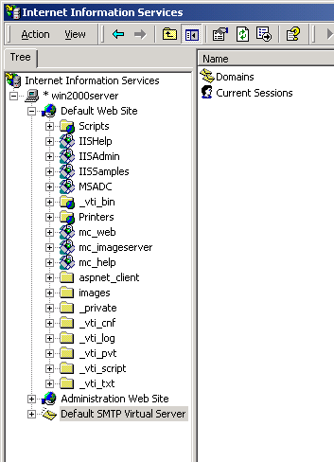
- Install/verify that they have SQL Tools (check Start -> Programs -> MS SQL Server -> Enterprise Manager). If they do not have SQL Tools, install them on the Database server. If they have SQL Server 2000 you will install there copy, if not then install your personal copy (see note 6) (be sure to remove your personal copy before you leave).
Note 6) You can download a trial version of MSDE Client Tools from http://www.maintenanceconnection.com/mcv18/mc_download/. This is a fully operational trial version that will expire after a few days so you should uninstall it after you are done.

Maintenance Connection Setup on IIS
- Load IIS Manager (Start -> Programs -> Administrative Tools -> Internet Information Services, you may have to access Administrative Tools through the Control Panel on some computers).
- Expand the local computer
- If it exists, click on Web Service Extensions – it is after FTP Sites, Application Pools and Web Sites. Then make sure that Active Server Pages is “allowed”. If it does not exist remember for later steps (This is only important for 2003 Server and up).
- Expand Web Sites.
- Expand the Default Web Site
- Create a new Virtual Directory under the default web site (Right click -> New -> Virtual Directory).
- Name: “mc_web”
- Directory: “install location\mc_iis\”
- Permissions: Read [Only] and Scripts
- Right Click the new Virtual Directory and select Properties
- Prior to Windows 2003
    - Virtual Directory Tab -> Application Protection dropdown = “LOW”
- Windows 2003 –
    - Make sure, under Pools, that the app is in the default app pool
    - If Web Service Extensions did not exists then ENABLE ASP extensions.
    - Application Settings Area -> Configuration button -> Options Tab -> Enable Parent Paths = Checked
- Cache/Caching (Both)
    - HTTP Header Tab -> Click Enable Content Expiration
    - Select Expire after n days. (recommended 30 – 90 days)
- Create a new Virtual Directory under the default web site (Right click -> New -> Virtual Directory).
- Name: “mc_imageserver”
- Directory: “install location\mc_imageserver\”
- Permissions: Read [Only]
- Right Click the new Virtual Directory and select Properties
- Prior to Windows 2003
    - Virtual Directory Tab -> Application Protection dropdown = “LOW”
- Windows 2003 –
    - If Web Service Extensions did not exists then ENABLE ASP extensions.
    - Application Settings Area -> Configuration button -> Options Tab -> Enable Parent Paths = Checked
- Cache/Caching (Both)
    - HTTP Header Tab -> Click Enable Content Expiration
    - Select Expire after n days. (recommended 30 – 90 days)
- Create a new Virtual Directory under the default web site (Right click -> New -> Virtual Directory).
- Name: “mc_help”
- Directory: “install location\mc_help\”
- Permissions: Read [Only]
- Right Click the new Virtual Directory and select Properties
- Prior to Windows 2003
    - Virtual Directory Tab -> Application Protection dropdown = “LOW”
- Windows 2003 –
    - If Web Service Extensions did not exists then ENABLE ASP extensions.
    - Application Settings Area -> Configuration button -> Options Tab -> Enable Parent Paths = Checked
- Cache/Caching (Both)
    - HTTP Header Tab -> Click Enable Content Expiration
    - Select Expire after n days. (recommended 30 – 90 days)
- Close IIS Manager.

Database Preparation
- From Windows Explorer, create a database backup directory (usually “c:\DBs\Backup\”)
- Open the SQL Enterprise Manager
- Drill down until you see the (local) database. (Console Root -> Microsoft SQL Servers -> SQL Server Group)
It may have the name (local) or it may have a specified name. It appears that, by default, if you are running Standard MS SQL Server it will show the computer name, if you are running the Runtime version it will show (local).
- Find the Securities Tab on the Properties for the (local) database.
- Set “Use SQL Server and Windows Authentication”.
The default for the runtime database and our test installation of Standard MS SQL Server is Windows only.
- Stop and restart the service. This will take a few minutes.
- Drill down to security.
- Add a user (new login on some versions):
User Name: “mczar”
Password: “mczar”
Use SQL Authentication
- Change the “sa” account password from the default setting “sysadm”
If you do not change the sa password it will leave the SQL Server vulnerable to attack.

Maintenance Connection Setup Manager
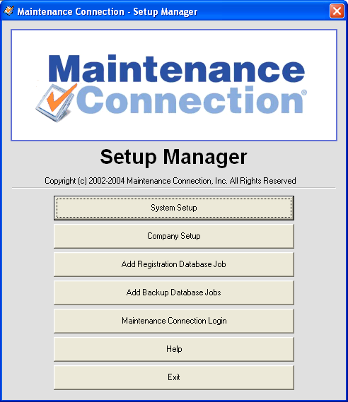
- Using Windows Explorer, navigate to the “install dir”.
- Run “mc_setup.exe”
The Setup Manager will setup the Registration and the Company Databases. It will also register the supporting DLL’s and initialize the information Maintenance Connection needs.
- Start by clicking the System Setup button
  - Fill out the Registration Database Access information first
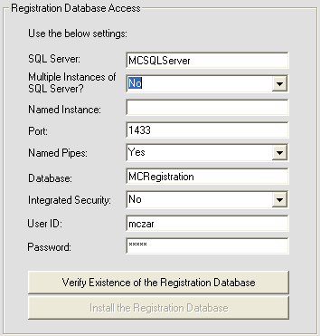
  - SQL Server: The name of the SQL Server
  - Multiple Instances: Set to ‘yes’ if you have more than one SQL Server Instance on the SQL Server
  - Named Instance: Fill in if Multiple Instances is set to yes.
  - Port: The SQL Server Port. Usually 1433, sometimes 1432.
  - Named Pipes: Usually ‘yes’ set to ‘no’ if not using named pipes.
  - Database: This is the name of the Registration Database, usually “mcRegistrationSA”.
  - Integrated Security: Leave as ‘no’.
  - User ID: The SQL Server user ID, should be ‘mczar’.
  - Password: The SQL Server user password, should be ‘mczar’.
- Click the Verify Existence button (alternate database restore option, see Appendix 1).
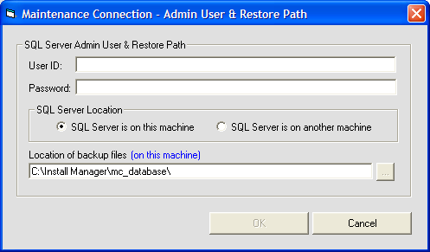
  - User ID: This is the user ID for the SQL Server system admin account (usually sa).
  - Password: This is the password for the system admin account.
  - SQL Server Location: If the SQL server is on this machine or a remote machine. This tells SQL Server were to create the databases.
  - Location of the backup file: This is the location of “\Maintenance Connection\mc_database” folder from the SQL Servers perspective. If the SQL Server is a different machine then you need to copy the mc_database folder onto that PC.
  - Select the OK button to create the database and/or the user.
- Next, fill out the Company Database Access information.
(Note: You will need to check the use single company checkbox if it is not already checked.)
If you are setting up a demo database as well as a customer database – make sure this check box is NOT selected.
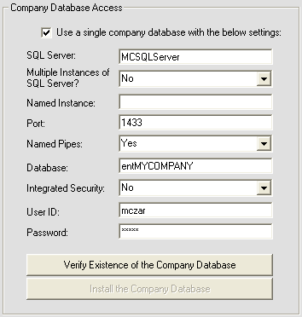
  - This information should be the same as the Registration Database Access information, except for the Database field.
  - Database: This is the name of the Company Database. The first three letters should be ‘ent’ all lower case. The next part is the Abbreviation for your company, all upper case. Example: MYCOMP, MAINTCON, or XYZ.
- Click the Verify Existence button.
Note: until you hit the Save button, the records in mcRegistrationSA’s Container and Container_Resource tables are not added! If you hit Cancel – the database will be created but the database records are not.
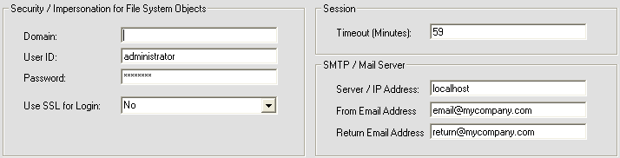
  - When prompted to install the Company Database, click yes and complete the following screen the same as when installed the registration database
- Next, fill out the Security, Session, and SMTP fields.
  - Domain: This is used for File System Object Impersonation. If you are using a local user account, you can leave this field blank. Note: There are problems on some systems with Domains. In general – create a LOCAL USER and use that user for Object Security. If when you test saving objects, you get an error that you don’t have permission to save users, thy this:
    - Create a LOCAL user (no domain)
    - Give that use full permissions on the maintenance connection directories
    - Run the diagnostics page by clicking of the logo on the login page.
    - Reload the ini.
  - User ID and Password: This is the login for a Windows User that has right to file manipulation.
  - Use SSL for Login: If using SSL, set this to ‘Yes’.
  - Session: Set the timeout to 59 if not already set.
  - SMTP / Mail Server: Fill in the IP or Server Name of your SMTP Server.
  - From & Return Email Address: These addresses are used when sending emails from the Reports Module. A good example of what they should be is provided in the image above. You may need to create the email accounts.
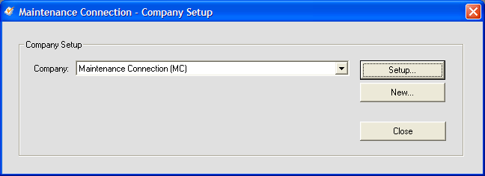
- Click Save once all the steps are completed.
- From the main screen click Company Setup
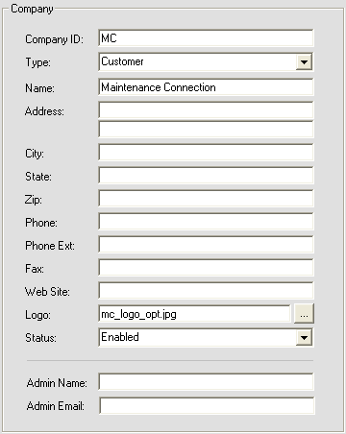
- Click the setup button
- Fill in the company information first
  - Company ID: Fill this in as the abbreviation for your company, all upper case. This should be the same as the company database name without ‘ent’.
  - Fields ‘Name’ down to ‘Website’ are informational only. Fill in as much as you need.
  - Logo: If you have a logo, use the browse button to find it. The file must be located in “\Maintenance Connection\mc_imageserver\ent” + company abbreviation.
If you don’t have a logo this field should be blank.
  - Admin Name: This name is used when new signups are being requested.
  - Admin Email: This is the email for the administrator of the software.

- Next fill in the Security and License information.
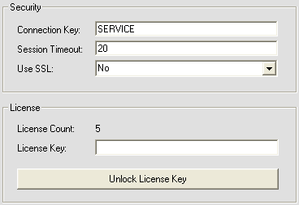
  - Connection Key: This is used when new users are signing up for the software.
  - Session Timeout: Set this to between 20 and 59. Anything over 59 will cause an error in Internet Explorer.
  - License Key: This is used to update your number of licenses. Fill in with the License Key that Maintenance Connection provided you and then click Unlock License Key. If prompted to save, click yes.
- Ensure the SQL Server location is correct. If not then enter the correct server name. If using named instances ensure the server name is “servername\instancename”.
- Click save to exit this screen.
- Now that you are back on the main screen, click on Add Registration Database Job.
  - This will create a SQL Server Job that will clean up old sessions each night at 2:00am
  - You may be prompted for the SAL Server administrator user name and password.
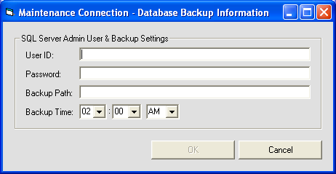
- If you would like to create Backup Jobs, click on Add Backup Database Jobs.
  - User ID: This is the System Admin (sa) user for the SQL Server.
  - Password: The System Admin password for the SQL Server.
  - Backup Path: This is the path to the folder where you would like your backups stored. This is the directory that you created earlier for file backups (c:\DBs\Backup\).

Finishing Up
The system should now be ready to go. Go to http://webservername/mc_web to access the application. Use username: admin and password: admin to log on.

Appendix 1 (Restoring MC Databases Manually)
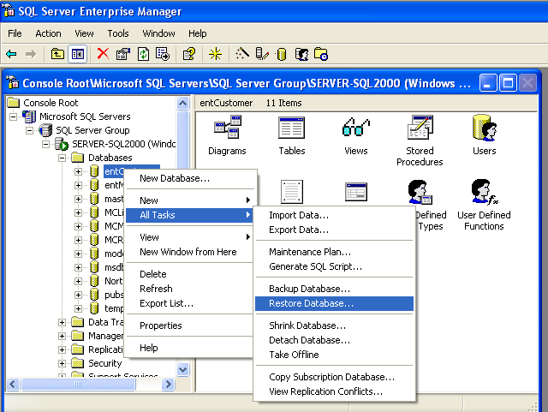
- Open Enterprise Manager or SQL Server Management Studio (SSMS)
- Drill down in the tree to the database server and the databases folder.
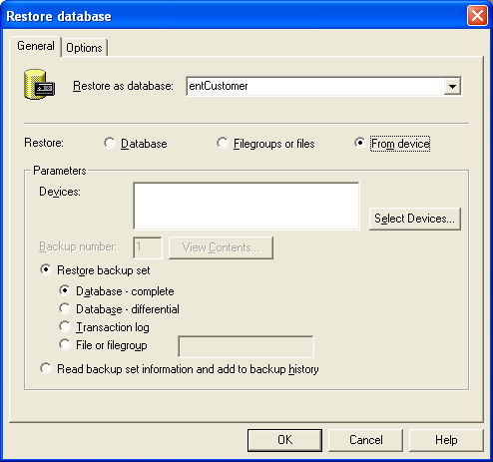
- Right click and select All Tasks → Restore Database…
- Change the name of the database to restore as; this will be mcRegistrationSA or ent??? for customer databases.
- Change the restore type to From Device.
- Select: Select Devices…
- Select Add
- Type in the name of the database being restored or select the database using the ellipsis button (…)
- Select OK
- Select OK again
- Ensure that you select the backup set to restore (SSMS only)
- Select the Options tab
- Change the restore location of the database and log file to a valid directory location. Database files should end with “.mdf” and log files should end with “.ldf”.
- Select OK to begin the restore.
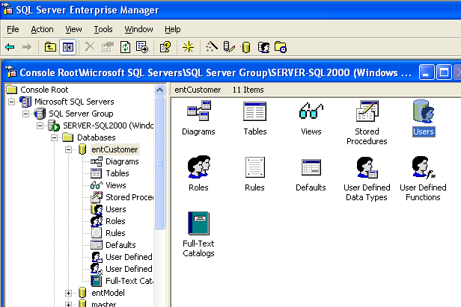
- Repeat steps 3-14 for each database being restored. Usually this will be mcRegistrationSA.bak and mcModel.bak. mcModel is used for restoring customer databases and should be restored as an ent??? database.
- Select the newly restored database and drill down to the users area.
- Select Add User
- Add a user named mczar and select the login mczar from the dropdown list.
- Make sure the user has db owner permissions.
- Done!

