MC Active Directory
Installation Process

About
The Maintenance Connection LDAP/Active Directory Connector tool is used to setup the links and mapping information from an LDAP source to the Maintenance Connection user list and access group settings. Once the configuration has been completed, a LDAP syncing service can be installed which will, on a scheduled basis, setup new users for MC access and update existing users with the appropriate access rights.

Pre-installation
- Make sure that Maintenance Connection has been installed and is working consistently.
- Ensure that appropriate permissions have been granted within Active Directory to have either anonymous querying of the Domain or a user has been setup that has sufficient permissions.
- Check that the IIS Server has been attached to the Active Directory domain.
- Download the install files.

Configuration
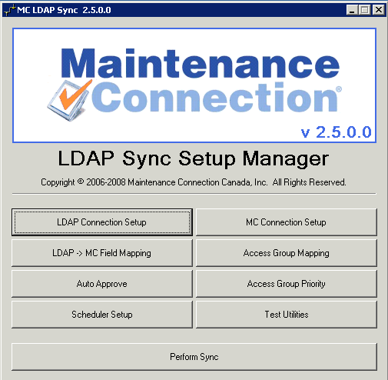
The first time the configure.exe executable is run a product license request will show before the configuration can begin. Refer to Appendix A for directions on how to activate the product.
This is the main dialog of the configure.exe executable, a launching point for setting up the links and testing the syncing functions. Configuration progresses from left to right and top to bottom along the dialog.
Test Utilities contains a number of test tools that can be used to find LDAP fields and check for the existence of certain records within the LDAP directory. This is used to diagnose when unexpected results occur during a sync process.
Perform Sync contains a number of synchronization options. It will be used to perform manual synchronization operations as part of testing the configuration settings.

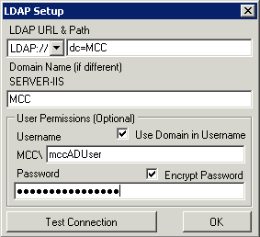
LDAP Connection Setup
The LDAP Setup screen allows you to specify the connection to the LDAP source.
- Fill in the LDAP URL & Path to the LDAP source.
- If the Domain Name is reporting incorrectly enter the correct domain name
- If required by LDAP, enter the user that will be used to access the directory.
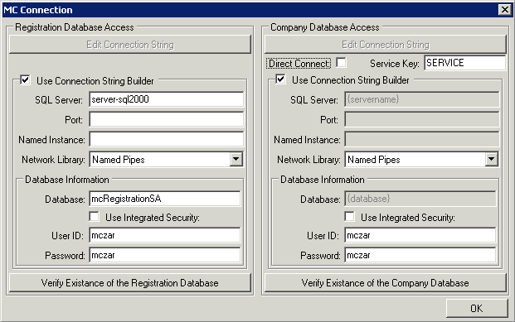
- Test the connection.

MC Connection Setup
The MC Connection Setup screen will allow you to setup the SQL Server connection strings.
Use either the Connection String builder or directly edit the connection strings. Be sure to verify the connections to the databases by clicking the verify buttons on the bottom of the dialog.

LDAP / MC Field Mapping
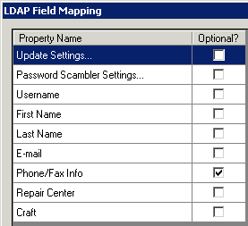
The LDAP Field Mapping setup screen will allow you to specify which fields from LDAP will map to fields in Maintenance Connection. Most of the information is pre-populated with typical settings from Active Directory. The mappings are grouped and each group is displayed on the left side and when selected the properties associated with that group will display on the right.

Update Settings…
- Disable Update from LDAP
This setting will make the LDAP service only import users into Maintenance Connection. Once users have been imported changes to their user record in LDAP will not be reflected in MC.
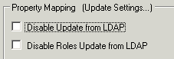
- Disable Roles Update from LDAP
This setting will import and update users from LDAP but will not update the Maintenance Connection Access Group associated with the user if the users group settings change. This is for LDAP to be used as a master users list. Security permissions will be controlled by Maintenance Connection and not LDAP.

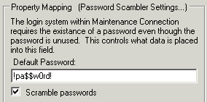
Password Scrambler Settings…
The default login system in Maintenance Connection requires passwords to be stored in the database. Since the LDAP extensions build on top of the default login system passwords are still needed in the database for everything to function normally. These passwords are not actually used for logging in, but they can be discovered. For additional security the Password Scrambler has been provided to generate completely random passwords in the database.

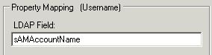
Username
This is the field in LDAP that will map to the Maintenance Connection username. It will also be used as the users Labor or Requestor ID.

First Name
This is the field in LDAP that will map to the Maintenance Connection Labor/Requestor first name field. If updates are turned on, this field will also be updated when/if the users name changes.

Last Name
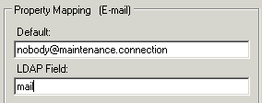
This is the field in LDAP that will map to the Maintenance Connection Labor/Requestor last name field. If updates are turned on, this field will also be updated when/if the users name changes.

E-mail
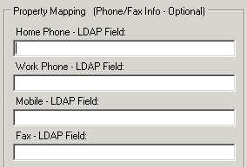
This is the field in LDAP that will be used to provide the Maintenance Connection Labor/Requestor with an e-mail address. Maintenance Connection requires that all users have an e-mail address since certain actions within MC can generate e-mails. Whenever a user in LDAP doesn’t have an associated e-mail address the default e-mail address will be assigned to the user.

Phone/Fax Info
These fields in LDAP provide the phone contact information for the Maintenance Connection Labor/Requestor records. These are not required fields and can be ignored if desired.
The phone numbers are unformatted 30 character fields. Any phone number of 30 or fewer letters and numbers will be accepted. If no LDAP field is provided or the field is not filled in on a LDAP user the field in Maintenance Connection will be left blank.

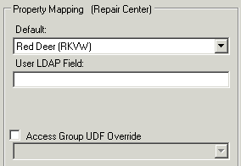
Repair Center
Repair Center is a required field in Maintenance Connection and is managed on a user by user basis. The MC LDAP Service extends this functionality to allow Repair Centers to be assigned to users based on their assigned Access Group.
The default value is required in the case that no valid Repair Center is found in the Access Group or LDAP field.
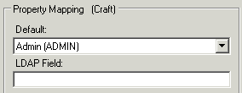
When the Access Group UDF Override is enabled you will be able to select a User Defined Field associated with Access Groups. This field can be used to specify the ID of the repair center to assign to users being assigned to the Access Group.

Craft
A Craft must be assigned to all Maintenance Connection Labor records. The default will be used when the LDAP field does not contain a valid Craft for users.

Access Group Mapping
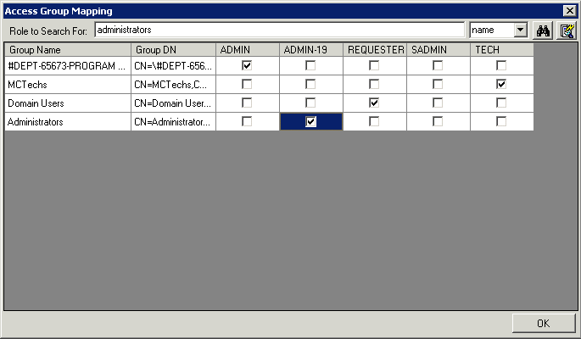
The Access Group Mapping screen shows a grid of LDAP groups with a separate column for each access group inside of Maintenance Connection. By checking a box for a specific LDAP group and Maintenance Connection Access Group, it specifies that any LDAP user contained in said LDAP group should be linked to the specific MC group.
To add LDAP groups to the grid you must search for each required LDAP group individually by typing the name in the Search box and clicking the Search button.
The button to the right of the Search button will load a list of all LDAP groups in the entire directory. This can be a very slow process so it is only recommended if the number of groups in the directory is known to be few.

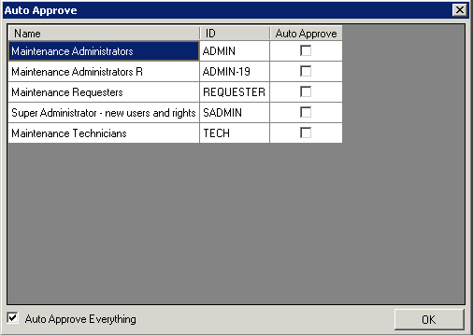
Auto Approve
The Auto Approve screen controls how member approval is performed.
By default, the “Auto Approve Everything” check box is checked. This will auto approve any new member created, regardless of the Access Group. If you uncheck the Auto Approve Everything check box, and leave everything else unchecked, the members will be created but will require approval in the Maintenance Connection system prior to logging on. Alternatively, if you only want to approve certain groups, you can check the box next to them. An example would be where you would want to automatically approve requesters but require manual approval of other access groups.

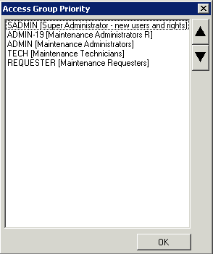
Access Group Priority
The Access Group Priority will bring up the dialog for specifying which MC Access Groups have a higher priority when it comes to a LDAP user.
If a LDAP user exists in more than one LDAP group that is linked to a MC group, the syncing tool needs to know how to specify which access group the user belongs to inside of Maintenance Connection. The access groups at the top have higher priority than the groups below them. For example, if a user should be created as an ADMIN instead of a REQUESTER, ADMIN would need to be higher on the list.

Testing the Configuration
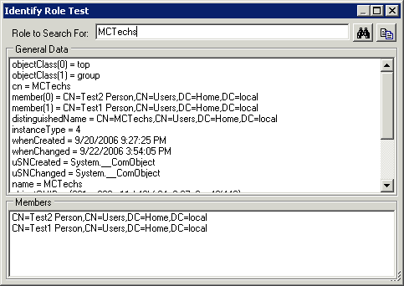
Once the configuration is complete it needs to be tested to ensure users are going to be transferred as expected. This process will require the use of the Test Utilities, Identify Role and Test User Mapping.
To find out how users will map into Access Groups in Maintenance Connection you will need to identify what users belong to which LDAP roles.
- Open the Identify Role test utility.
- Search for one of the LDAP roles that will map to an Administration type Access Group.
- At the bottom of the screen will be a list of the users found that belong to that role, write down one or more of them to perform mapping tests upon.
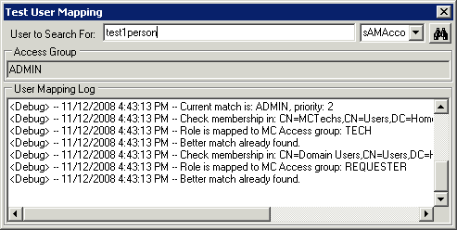
With a list of users that are known to be valid and being considered for membership in Maintenance Connection you can test the mapping process to ensure that the selected users are mapping as expected into Maintenance Connection Access Groups.
- Open the Test User Mapping utility.
- Enter the user name of a known valid user.
- Select search.
- Compare the Access Group specified with the Access group expected.
- If the Access Group is not the one expected, read through the Log information to see how the mapping process occurred.
- Make changes as required to Access Group Mapping.
- Repeat the process a few times until confident in the Access Group mapping.

Preparing the Database To Synchronize
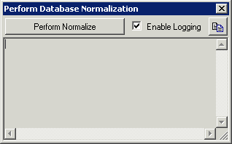
The Maintenance Connection LDAP Service requires additional fields to be present in the Registration database before it can successfully perform its synchronization processes. To update the database with required new fields as well as identify and upgrade from a previous version of the LDAP Service you must perform a database normalization process.
- Open the Perform Sync dialog.
- Select Normalize Old LDAP Users.
- Select Perform Normalize to begin the normalization process.

Performing a Manual Sync
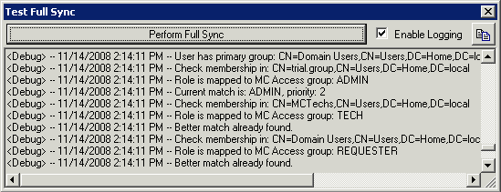
Performing a manual synchronization process is essential if the automatic synchronization has been disabled or the first synchronization has not yet been performed. The manual sync process allows the user to watch the process as it occurs and after it has completed the user can look back through a detailed log and discover the decision process used to sync users from LDAP into Maintenance Connection. A manual sync can be performed in a limited fashion through a Limited Sync, which will allow only one LDAP user to be synchronized at a time, or through a Full Sync, which does a complete deep scan of the LDAP directory and synchronizes all available users.
If the results of synchronization are not as expected the log output can be copied to the clipboard using the convenient copy button in the top right corner. The log can then be forwarded to technical support should assistance be required.
A manual sync should be performed after a successful configuration as well as after a program upgrade. This will ensure a log file of the sync process is captured and any unexpected results are caught. Performing a manual sync can occur at any time without causing issues with the MC LDAP Service running in the background.

Scheduler Configuration
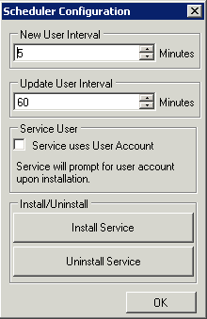
The Scheduler Configuration screen will bring up the dialog for installing the service and setting the sync intervals.
The “New User Interval” is used to determine how often new users will be searched for in LDAP and created.
The “Update User Interval” determines how often the Access Groups and mapped fields of the Maintenance Connection member records are updated for existing users.
By clicking the “Install Service” button, the service will get installed and set to automatically start; however, it will need to be started manually from Windows Services the first time.

IIS Setup
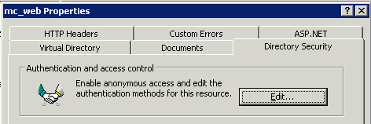
To enable the LDAP extensions in Maintenance Connection; IIS must be reconfigured to require authenticated access to the mc_web virtual directory.
- Open the IIS Manager.
- Navigate in the IIS Manager to the mc_web virtual directory.
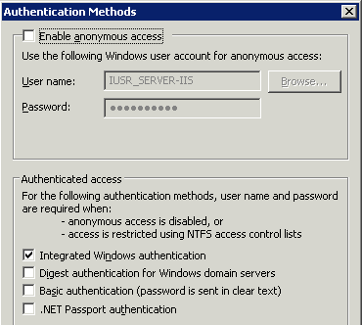
- Right mouse and select Properties.
- Navigate to the Directory Security tab.
- In the Authentication and access control area, Select Edit.
- Uncheck “Enable anonymous access”.
- Check “Integrated Windows authentication”.
- Make sure the other authentication methods are unchecked.
- Select OK and exit IIS Manager.
To enable automatic LDAP login in Maintenance Connection.
- Open the file browser.
- Navigate to the LDAP tool install folder.
- Copy all files located in the “mc_iis” folder and sub-folder(s).
- Paste the files into the “\Maintenance Connection\mc_iis\” folder.
- Rename the file “default.asp” to “default_normal.asp”.
- Rename file “default_ldap_MCC.asp” to “default.asp”.
- Close the file browser.

Installing Errors Report
In the case where synchronization errors occur after installation a special report has been created to allow the viewing of these errors.
- Open SQL Server Management Studio or Query Analyzer.
- Open the file named “ADErrorLog.sql” located in the “reports” folder below the LDAP tool install folder.
- Point the SQL Query at the Entity database (often named entCustomer).
- Execute the query.
- Upon successful completion of the query, the report “AD Error Log” will be added to the System Reports group.

Appendix A (Product Key Activation)
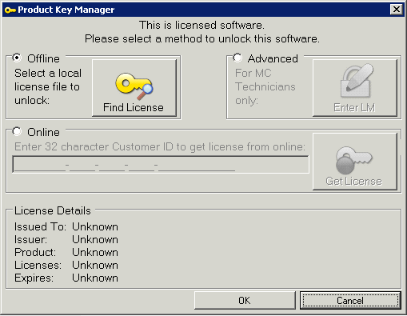
This product needs to be activated by a license key before use or configuration. There are 3 activation processes that can be used to activate this product. All three are available to simplify the activation process and only 1 process need be followed.

Offline Activation
- Select Find License
- Find and select the previously issued MC LDAP Connector license key file.

Online Activation
- Enter the 32 character Customer ID in the field provided.
- Select Get License to retrieve the license key from the remote Maintenance Connection license server.

Advanced Activation
This method is only for Maintenance Connection technicians who have valid license server credentials.
- Select Enter LM.
- Enter your license server credentials.
- Select the Customer from the customers list.
- If the Customer record does not exist, create the customer.
- If a product license has not yet been issued for the customer, it can be created here.

